Section | Details

Product Type | Line diffuser
Light source information | Type of light source  (VCSEL/EEL/PCSEL)
 | Divergence Angle  (Full Width at 1/e^2 Maximum Intensity) | Min：$°$
 |  | Typical：$°$
 |  | Max：$°$
 | Radiation Characteristics¹  (Please provide detailed specifications) | See example in appendix
 | Optical aperture
 | Number of emitters
Emitter arrangements
(Please provide pattern, pitch, and coordinates)
 | Wavelength
Metalens mechanical dimensions | Size of active area  (Standard size 2.5mm x 2.5mm)
Size of metalens
(Standard size 2.8mm x 2.8mm)
Performance specifications | Efficiency
Output divergence angle, H x V
(Angle at 1/e^2 Maximum Intensity)
 | Expected intensity distribution curve
 | Line width @ test distance
 | Uniformity²  (Standard deviation, Peak to valley (PV)) | See appendix for equation
Number of samples used for uniformity calculation
(Default value is 700)
 | Test method for intensity characterization (Please select the intended method) | Method 1:  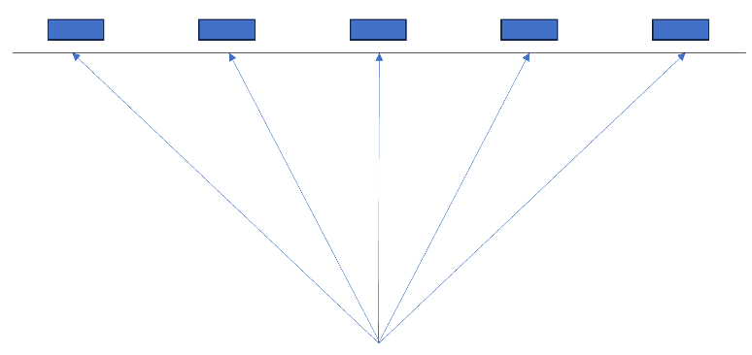  Method 2:  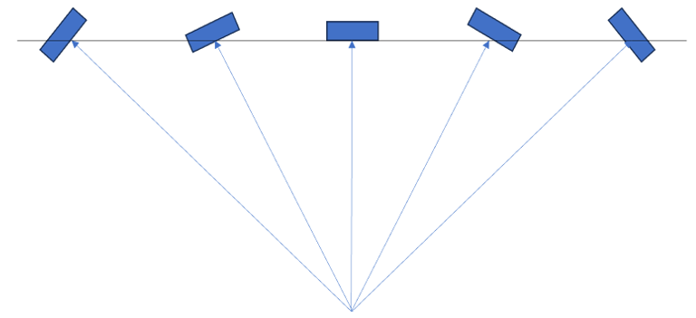
Assembly Requirements  (if any) | Assembly requirement  (Lens only / Assemble with light source)
 | CAD or dimension requirements of pre-determined lens holder or lens assembly
Preferred alignment method
(Active alignment or tight fit alignment)
 | Alignment error in XY axis
 | Alignment error in Z axis
 | Rotation error around Z-axis
Others | Fill in any other requirements here

Appendix
1. Radiation Characteristics Example | 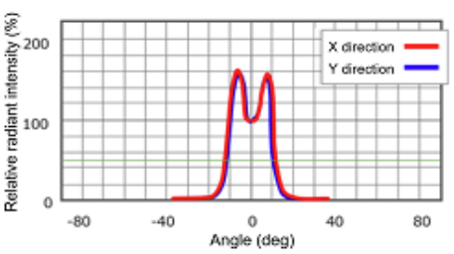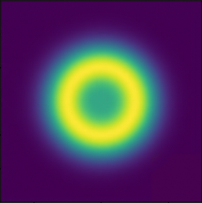
2. Uniformity calculation | Standard deviation: $\sqrt{\frac{{\sum_{i=1}^{n}{\left(x_{i}-\overline{x}\right)}}^{2}}{n × {\overline{x}}^{2}}}$ PV value: $\frac{I_{max}-I_{min}}{I_{max}}$

