Section | Details

Product Type | Dot projector
Light source information | Type of light source  (VCSEL/EEL/PCSEL)
 | Divergence Angle  (Full Width at 1/e^2 Maximum Intensity) | Min：$°$
 |  | Typical：$°$
 |  | Max：$°$
 | Radiation Characteristics¹  (Please provide detailed specifications) | See example in appendix
 | Optical aperture
 | Number of emitters
Emitter arrangements
(Please provide pattern, pitch, and coordinates)
 | Wavelength
Metalens mechanical dimensions | Size of active area  (Standard size 2.5mm x 2.5mm)
Size of metalens
(Standard size 2.8mm x 2.8mm)
Performance specifications | Efficiency
 | Output divergence angle, H x V
 | Total number of dots
 | Tile arrangements m x n
 | Contrast ratio² | See appendix for test condition
Assembly Requirements  (if any) | Assembly requirement  (Lens only / Assemble with light source)
 | CAD or dimension requirements of pre-determined lens holder or lens assembly
Preferred alignment method
(Active alignment or tight fit alignment)
 | Alignment error in XY axis
 | Alignment error in Z axis
 | Rotation error around Z-axis
Others | Fill in any other requirements here

Appendix
1. Radiation Characteristics Example | 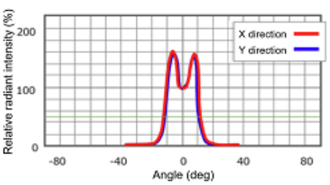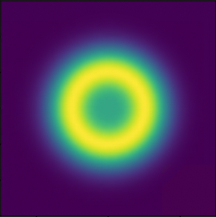
2. Contrast ratio calculation | 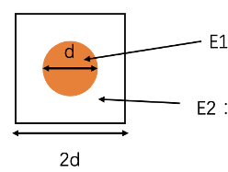  E1: Total optical power within spot diameter d  E2: Total optical power within a square with 2d side length  Contrast ratio = E1/E2

